

Model company - Dashboarding

# Introduction

You are commissioned by a company selling models and scale models. The company already has a database that lists employees, products, orders, and much more. You are invited to browse and discover this database. The director of the company wishes to have a dashboard which he could refresh each morning to have the latest information in order to manage the company.



# Objective

Your dashboard should revolve around these 4 main topics: sales, finance, logistics, and human resources.

Here are the indicators that should be present in your dashboard. Visualizations would also be appreciated. And you are invited to practice **your advisory role,** **by** **proposing additional KPIs and charts**.

* **Sales**: The number of products sold by category and by month, with comparison and rate of change compared to the same month of the previous year.
* **Finances**:
  + The turnover of the orders of the last two months by country.
  + Orders that have not yet been paid.
* **Logistics**: The stock of the 5 most ordered products.
* **Human Resources**: Each month, the 2 sellers with the highest turnover.

Nota bene: sometimes business indicators are not technically achievable. It is up to you to explain it, and to bring your own ideas to answer the business needs.



# Resources

Here is the diagram of the database :

# 

*source :* [*https://www.mysqltutorial.org*](https://www.mysqltutorial.org/getting-started-with-mysql/mysql-sample-database-aspx/) *for the schema, and lots of modifications for datas*

# 

# Tools

The manager does not want to do SQL, he wants to be able to access the data automatically and graphically. You can therefore propose a tool of your choice, as long as the dashboard is relevant.

For information, the database is available on a company server. You can access it in read-only mode with a user provided below.

The company also provides you with the script that you can run on your local MySQL server. The data are identical, and it stops at the end of the previous month.

On the morning of the demo, the data will be refreshed with new and fresh data (and you will be able to receive the update script if you do it locally). The demo should therefore display the latest available data.

**SQL Database**

You have the choice between connecting to the cloud server, or deploy the script locally. Data are identical in both ways.

**Local installation**

You will install a [MySQL Community server](https://dev.mysql.com/downloads/mysql/) on your machine, as well as the [MySQL Workbench client](https://dev.mysql.com/downloads/workbench/).

The database is ready to be loaded into a MySQL server. Connect to your server via Workbench, and run all [of the code in this file](https://drive.google.com/file/d/1NBa_ejFRETNhQj1Y9TXKMawJnmWHyNUX/view?usp=sharing).

**Cloud server**

You can connect to the MariaDB (a fork of MySQL) server of the company.

Hostname : 51.68.18.102

Port : 23456

Username : toyscie

Password : WILD4Rdata!

Example of connection with MySQL Workbench:

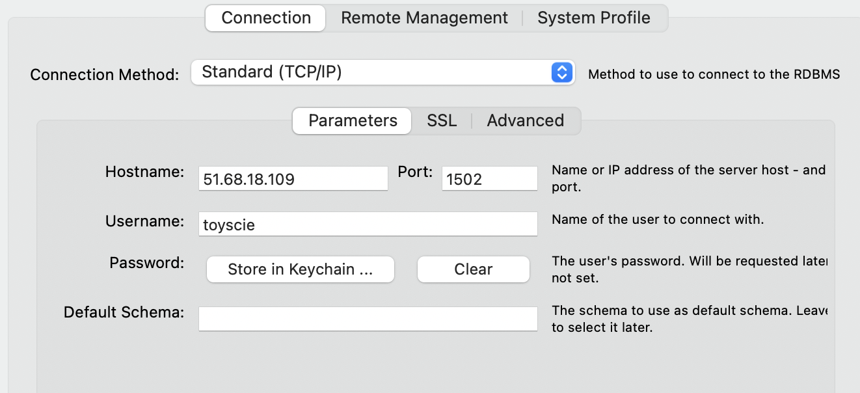

**Reporting tool**

You can use the tool of your choice. For information, the company uses Microsoft Power BI, so if you want to use it, you can see the PrintScreen to connect it. To be more collaborative, we have some print screens about connecting Google Data Studio to the cloud server. And of course, you can use other reporting Business Intelligence tools like Tableau Software. It’s up to you to present the best possible dashboard on the tool of your choice.

**Be careful: you chose your own reporting tool. But the goal is to practice SQL. So you need to get the data in SQL queries. For example, for the “2 sellers with the highest turnover for each month” :**

* **what we would like: a SQL query with only the “2 sellers with the highest turnover for each month”, and a dataviz to show this.**
* **what we don't want: a SQL query with every seller, then filters in your reporting tool.**

# Expected Deliverables

You will give a short presentation of your dashboard (ask for the duration at your trainer).



**Below: installation guide if needed**

**Microsoft Power BI: installation example**

You can [download and install Power BI](https://www.microsoft.com/en-US/download/details.aspx?id=58494) (**only for Windows users**). The dashboard will therefore be a PowerBI dashboard, connected to the MySQL server, and distributed on several tabs by theme. The manager can then refresh the data when he wants.

The first time you launch PowerBI, you have to select a data source. Here we select in “databases”: MySQL

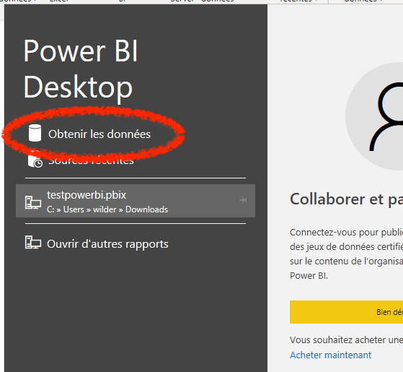

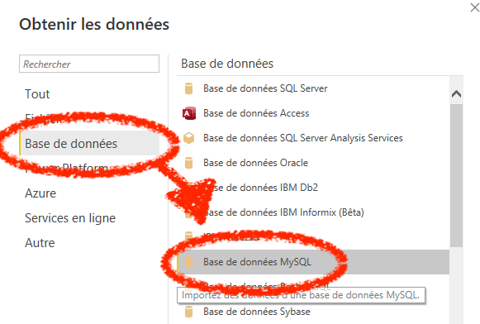

Maybe you’ll have this alert: you need a “connector” to connect MySQL and PowerBI

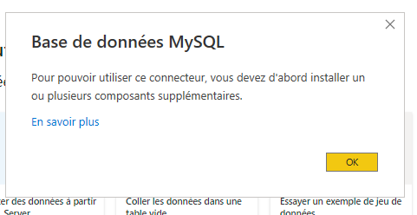

[Let’s go here to download the connector](https://dev.mysql.com/downloads/connector/net/), then install it:

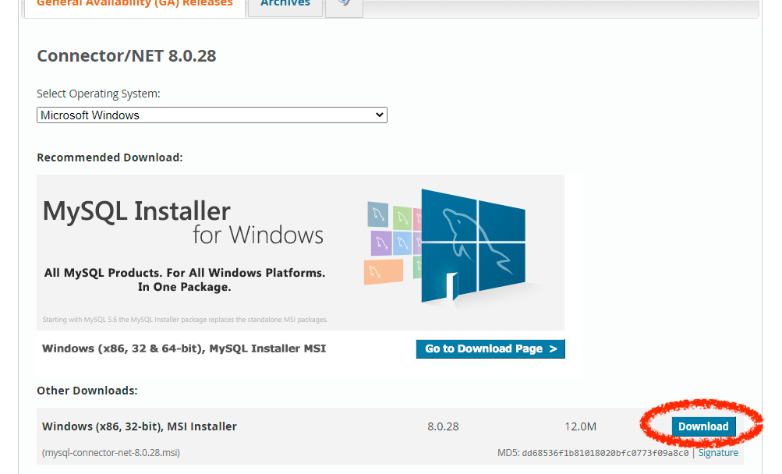

It’s not mandatory to create an account for MySQL:

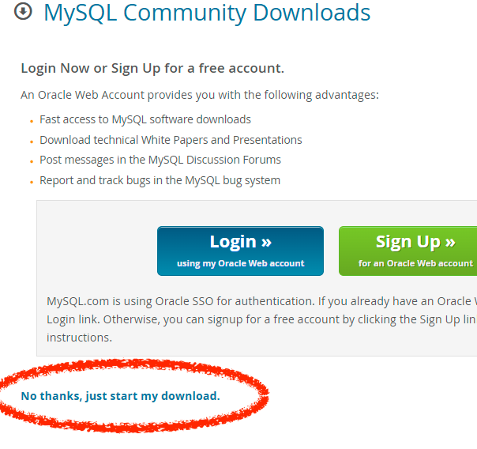

Then we can install it:

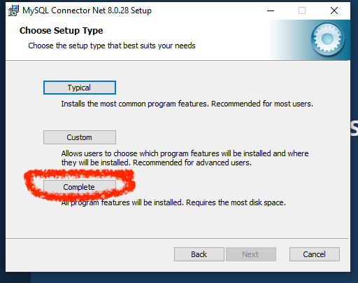

Now, please close and re-open PowerBI. You can now add a MySQL data source, where you can copy/paste your SQL query:

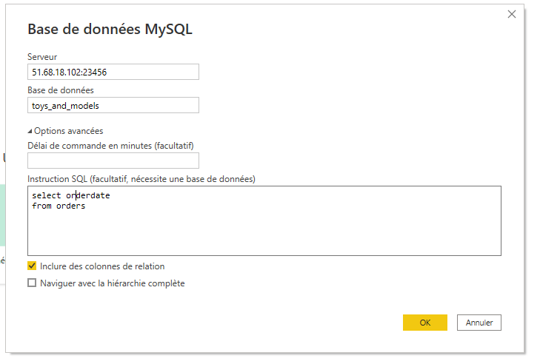

The first time you’ll connect to this source, PowerBI will ask you the login and password:

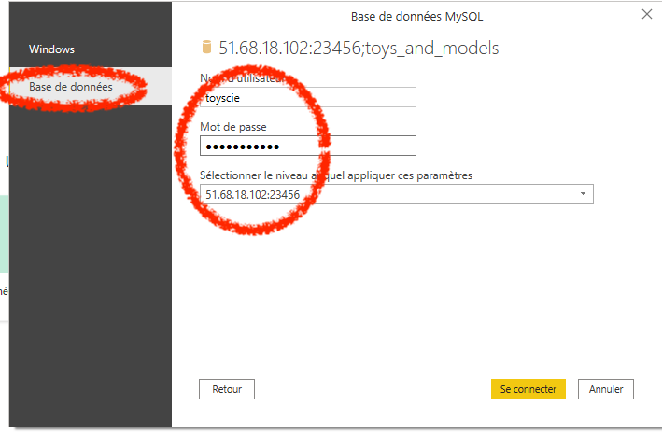

**Tableau Software: example of connection**

Tableau is available for macOS and for Windows.

Tableau public is totally free, but you can’t connect a SQL database.

Tableau for Student is a free one-year subscription. You [can reach it here](https://www.tableau.com/academic/students) with your alias ***@wilder.school*** and with your attendance certificate, that you’ll find on your Odyssey profile.

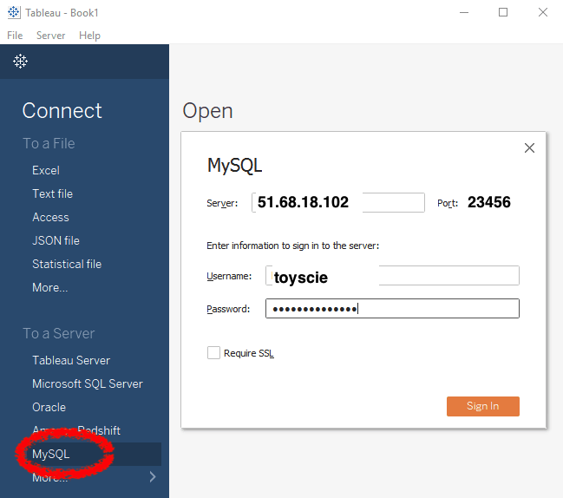

Then you can add a SQL query:

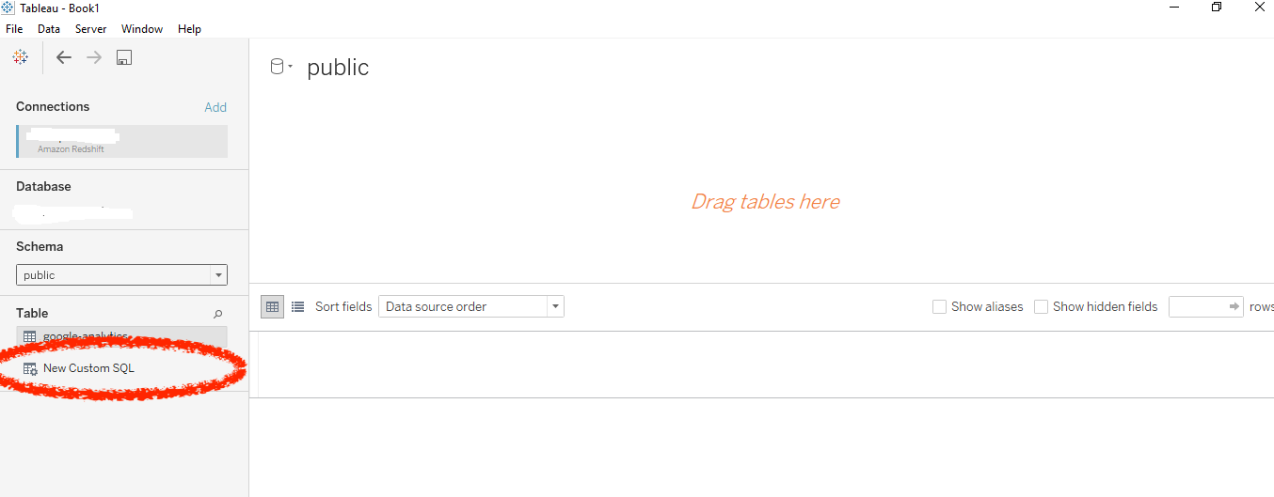

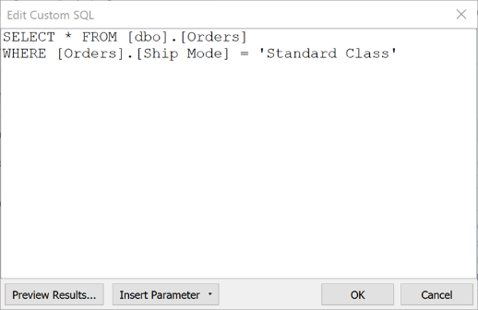

**Google Data Studio : connecting example**

Connect on the [Google Data Studio here](https://datastudio.google.com/navigation/reporting), and create a new “blank report”

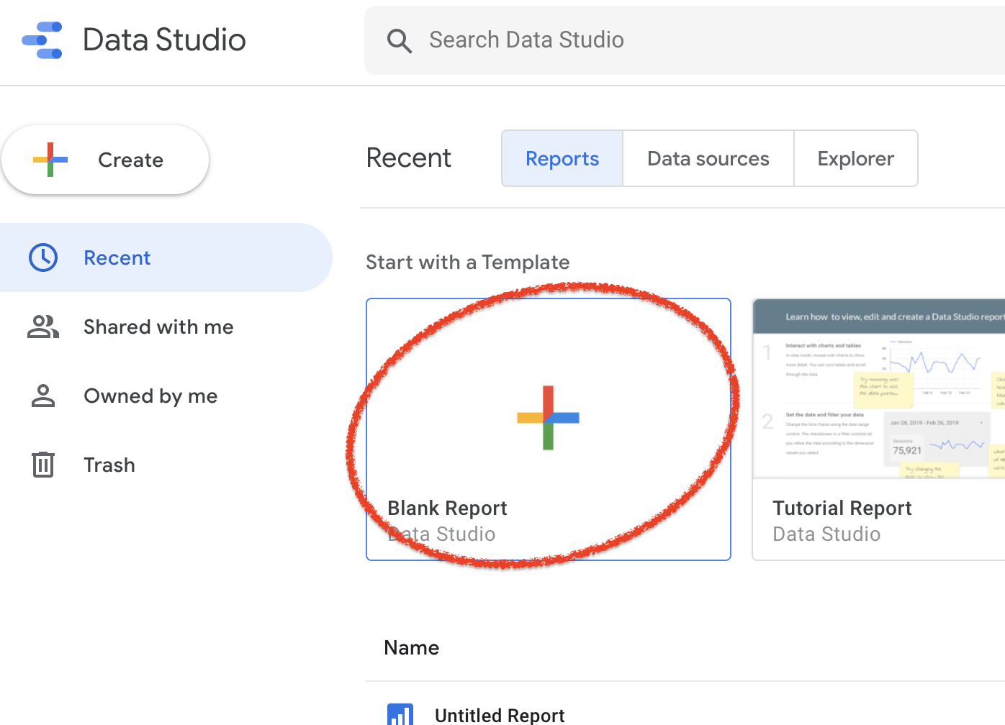

Search “mysql” and click on the good connector :

# 

# You can now authenticate, and write your own queries :

# 

# 

### 